

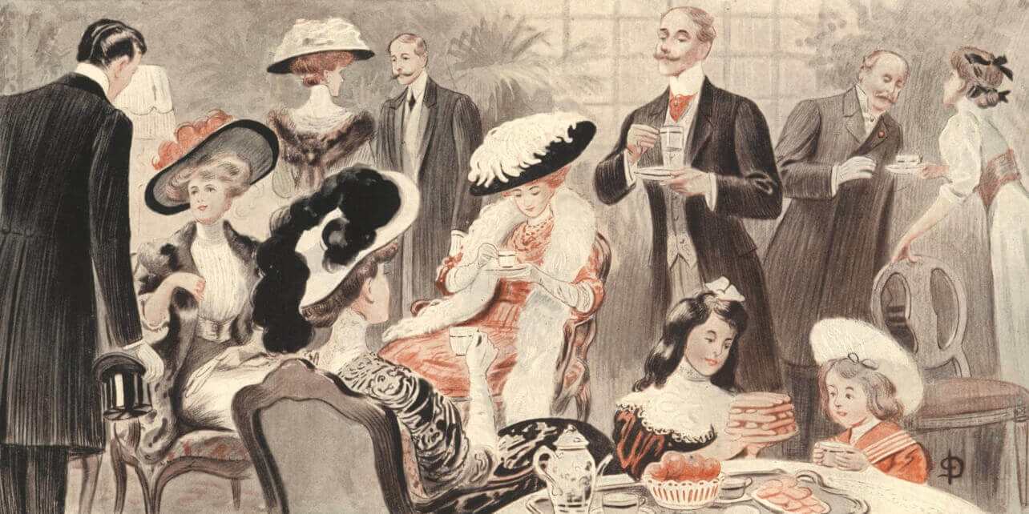

**BLOOM – A Place for Girls**

**A ministry of Adult & Teen Challenge New England**

***Presents***

**A Victorian Tea!**

**You are cordially invited to our first ever**

**Victorian Tea!**

Come donned in your most beautiful hat and tea attire and enjoy a beautiful afternoon tea with your closest friends!

Delectable sweets and savory treats, piping hot tea

and lovely fellowship await!

**Saturday, September 9th - 1:00pm**

$40 per guest

*All seating is general seating only.*

Special prizes for the best hat and afternoon tea attire!

*31 Center Street – Middleboro @ The Bridge*

**To purchase your tickets, please visit the Events tab at tcnebloom.org**